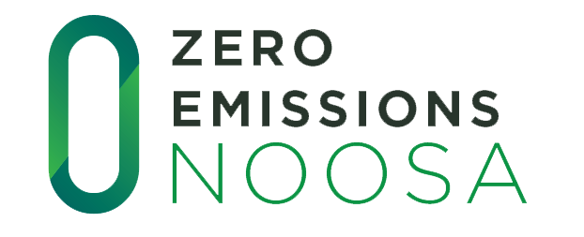

MEDIA RELEASE
FOR IMMEDIATE USE

ZEN’s Race to Zero helping schools reduce emissions

Schools across the Noosa Shire are utilising their real time energy data to learn about energy efficiency through Zero Emissions Noosa’s exciting initiative Race to Zero. The program provides students with access to their real-time energy data via www.solarschools.net and the Planet Watch APP. The program utilises a mix of direct curriculum teaching with week by week lesson plans and a gamified approach which shows students how their real time energy decisions impact on emissions.

Participating schools have access to their real time energy consumption and solar production data for use in the maths and science curriculum. The program engages students through a detailed look at how their real energy decisions at school impact on consumption and emissions. Exploring the data in the classroom is an exciting way to bring life to the classroom education. Participating schools include Noosaville, Tewantin, Federal, Sunshine Beach, Kin Kin and Cooroy Primary schools as well as Sunshine Beach and Noosa District High. Involvement is free of charge to all Noosa Shire schools.

“Schools are high energy consumers and the chance to curb wasteful energy use is important to the goal of reducing emissions across Noosa shire. The lessons learnt in school are taken home making this a highly valuable project for household back pockets as well as school bottom lines” said ZEN President Vivien Griffin.

Funded by the Noosa Council’s Environmental Grant schools are invited to participate and access free training sessions and classroom education. ZEN’s call is to curb wasteful energy behaviours and give meaning to the energy curriculum through real time data. Email info@zeroemissionsnoosa.com.au to participate or visit www.zeroemissionsnoosa.com.au for more information.

MEDIA RELEASE ENDS.

Media contact: Dalia Mikhail – 0419 773 640 or info@zeroemissionsnoosa.com.au

