Noosa Community Batteries Roadmap

Summary
Community group Zero Emissions Noosa Inc (ZEN) has been successful in receiving funding support from the Queensland Government’s Community Sustainability Action grant program to develop a roadmap to show how a large number of community batteries could be deployed across the Noosa Local Government Area and demonstrate the role that local storage can play in the transition to renewable electricity.

Rapid uptake in solar is causing ‘congestion’ in the electricity network, that is, more renewable energy than the grid can handle. Unfortunately, if renewable energy can’t be used, exported to the grid, or stored, it is wasted. Community batteries address this problem by absorbing and storing excess energy from rooftop solar and releasing it during peak times when it is needed most.

At the neighbourhood-scale, costs are shared, making energy supply and storage more affordable for everybody. We can retain energy storage “savings” in our local community.

Noosa is well suited to local storage having high levels of solar PV adoption, large and growing solar export, and many days where solar production exceeds demand. Rooftop solar all connect to the Low Voltage(LV) network that runs down our streets, and there is the opportunity to “soak up” the excess daytime electricity in a “sponge” to be “squeezed out” for night use by all customers, thus supporting the mantra of “generate local, store local, and use local”.

A community battery is one that delivers a sensible balance between the competing values of profitability, network support, decarbonisation and community benefit.

We expect that this specific roadmap for Noosa will be able to be easily adapted to other local government areas in South East Queensland in the Energex zone, and beyond, and used as a leading community model.

The roadmap will align with policy initiatives such as
- Queensland Energy and Jobs Plan
- Federal Government Powering Australia Plan
- Community Scale Battery Working Group policy advice

The intended audience for the roadmap will include
- the Noosa and Hinterland residential and business communities
- local enthusiasts for Community Batteries and the energy transition
- decision makers for stakeholders, which may include Noosa Council, Energex/Energy Queensland, investors, implementers and operators, other LGAs and government policy teams

The roadmap will prepare the groundwork for investors including the Federal Government’s commitment of $500k for a Community Battery in Noosaville, the State Government’s $500M for grid and community batteries, commercial operators, large green and local investors, and potentially Noosa Council and Energex. The plan will also consider how to scale the business and operational models to potentially well over 100 LV connected batteries across the Shire.

The roadmap will cover areas that are relevant to any community battery, as well as considerations for a small number of candidate locations.

General sections will cover
- site selection criteria
- community engagement
- connection to the Energex network
- top-level battery and equipment considerations
- business and financial models
- the operating model
- land, development and environmental approvals
- identifying partners for implementation of the roadmap
- identifying funding sources

A short-list of candidate sites will be developed with site specific detail for the general sections outlined above.

A Steering Committee of well-credentialed locals and recognised experts will guide the project and develop the roadmap in conjunction with local volunteers and project partners.

With community batteries, we can make our energy system more resilient, climate friendly, equitable, and affordable.

Project Overview
Community group Zero Emissions Noosa Inc (ZEN) has been successful in receiving funding support from the Queensland Government’s Community Sustainability Action grant program for a project to plan how a large number of community batteries could be deployed across the Noosa Local Government Area.

This particular goal was established in recognition of two factors:
- The need to rapidly reduce carbon emissions, utilising inter alia, continuing growth in rooftop solar installation;
- Recognition that the current grid network is not designed for the two-way flows created by solar exports.

The Problem
The Australian Energy Market Commission (AEMC) stated the problem succinctly:
Change is coming fast to the power system. Within a decade, half of all energy users will be using some form of home energy option like solar. The system wasn’t designed for power flowing both to – and from – consumers. Power networks aren’t incentivised at the moment to help customers get their solar back to the grid. We want to change that. Also, not everyone can export their solar energy because of daytime ‘traffic jams’ on the network. This problem doesn’t affect all solar owners yet, but it’s getting worse. If we don’t act, the system will reach its technical limits. Then, power networks will have to severely limit power exports or build costly new poles and wires to cope with the new solar on its way. Either way, we will all pay, so we need a smarter, cheaper way to use the grid. The sun is free, but poles and wires are not, so planning ahead will avoid costly over investment.

Objective
In response to these identified emerging issues, ZEN has commenced work exploring the role that community batteries on the Low Voltage(LV) network could play. The ZEN community group and Noosa Council have received requests from community groups, businesses, bodies corporate, individuals and Councillors about the introduction of community batteries in the Noosa LGA. We have been investigating initiatives in other jurisdictions to assess their viability to support time shifting of excess generated solar PV, increased solar hosting capacity, whilst also providing support in the low voltage network, all in a financially sustainable way.

To help meet the challenges of the energy transition and to meet zero emissions targets, we wish to collaborate with stakeholders to explore and define areas of mutual benefit in this space. It’s now time to plan how to best time shift the excess daytime solar electricity through a large number of strategically located batteries to support the Noosa community whilst providing support for our grid network.

This new roadmap will be the “Business Plan for a Network of Community Batteries in the Noosa LGA”, and will guide the pathway to grow from a single community battery, to a dozen, and in time to more than 100.

We expect that this specific plan for Noosa will be able to be easily adapted to other local government areas in South East Queensland in the Energex zone, and beyond, and used as a leading community model.

Zero Emissions Noosa, Inc
Zero Emissions Noosa is a community group in the Noosa Shire, whose members are committed to taking local action on climate change, particularly through reducing our reliance upon electricity generated from fossil fuels.

We believe the answer is sitting right above us, that is, using energy directly from the sun!

ZEN was incorporated in 2017 and has been working directly with Noosa Council and others to achieve net zero emissions in the Noosa LGA by 2026.

Website: zeroemissionsnoosa.com.au/community-batteries
Facebook: facebook.com/ZeroEmissionsNoosa

Motivations and policy alignment
Many of the motivations for this ZEN project have been validated and strengthened by the Queensland Energy and Jobs Plan(September 2022) which envisages Queensland’s electricity system in 2035, as a “smarter grid to support over 11 GW of rooftop solar and around 6 GW of batteries in homes and businesses” and increased renewable energy targets.

Actions of the plan include “invest(ing) $500 million for grid and community batteries”.
“As Queensland progresses toward its renewable energy target, batteries, firming and other storage options will become increasingly important for a reliable system.”
“….deployment of network batteries of different scales to provide additional energy storage
to store excess rooftop solar and improve network resilience. This means that more Queenslanders will benefit from the abundant solar energy in the system….” (ACTION 1.3)
“At the heart of the energy transformation is Queensland’s communities. The Queensland Government is committed to partnering with communities to maximise benefits
and regional opportunities.” (ACTION 3.6). Figure 1 shows the new Queensland renewable energy targets which will be legislated.

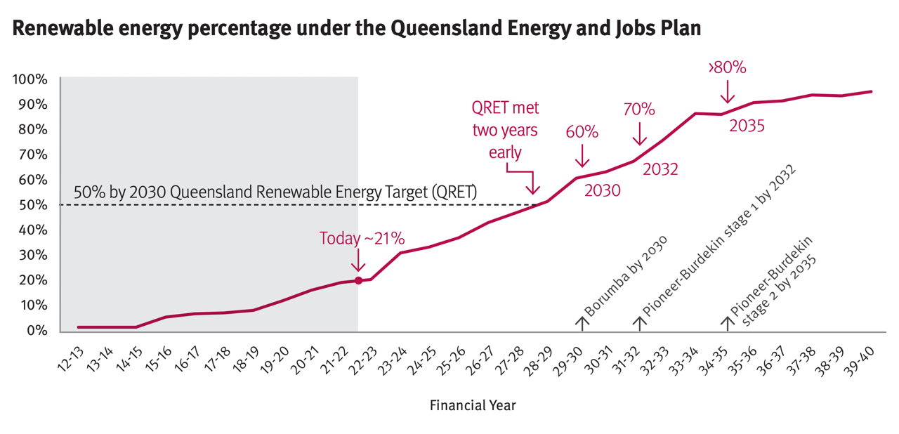
Figure 1
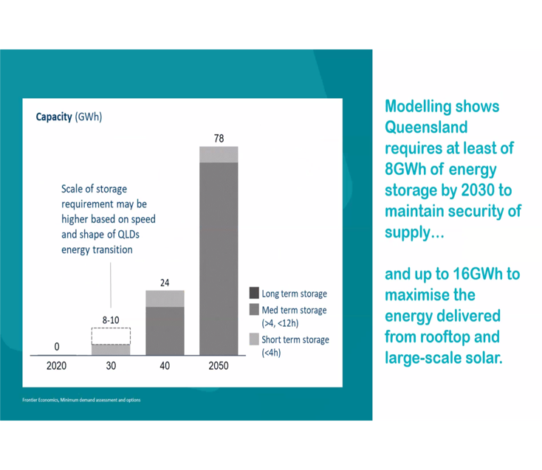
Prior to announcement of the new targets, modelling results as shown in Figure 2 had recognised the huge requirement for storage during energy transition to meet the then Queensland Government 50% renewable energy target by 2030.
Figure SEQ Figure \* ARABIC 2
If we take the Noosa LGA grid electricity consumption, as a percentage of the total grid electricity consumption in Queensland, this percentage corresponds to 65 - 130MWh of storage for the Noosa LGA. Not all of this storage would be needed locally, but it does highlight the enormous opportunity for significant amounts of local storage, close to the generation source. Note also that these storage estimates are for a Queensland 50% renewable energy target by 2030. Noosa Council and Zero Emissions Noosa’s target is more ambitious at 100% by 2026, so with higher levels of solar PV penetration, we can expect higher levels of storage will be required.
As rooftop solar grows, networks are challenged and reaching solar hosting capacity, particularly on Low Voltage(LV) feeders that run down our streets.

The Queensland Energy and Jobs Plan sets out the many types of energy storage that will be required, from large Pumped Hydro, large network connected batteries, community batteries as well as behind the meter batteries at customer premises. We also recognise the role of Dynamic Connections to adjust solar export, demand initiatives which will follow renewable generation profiles, plus how Electric Vehicles(EV) will impact on the LV network.

The impacts of the transition on the customer connected parts of the network are largely out-of-scope for the Queensland Energy and Jobs Plan and the market operator (AEMO) 2022 Integrated System Plan, but we see much work needed for the distribution networks.

Paraphrasing from the Queensland Energy and Jobs Plan, as a local community and Council, we can embrace many of the principles for the energy transformation including an inclusive approach to engaging and working with our community as partners in the energy transformation, to share the financial and other benefits of energy development with our local community, and build the capacity of our local community to realise the benefits from clean energy development, and positively manage changes associated with the energy transformation. Our project will empower local voices and local choices and position our community to see real and lasting benefits from increased economic development in our region.

ZEN’s project is also closely aligned with the Australian Government’s Powering Australia plan. The section on Community Batteries for Household Solar (page 22) spells out a policy for widespread adoption of community batteries very similar to our project, and is further articulated in the Power to the People policy (no longer available online) but summarised on the ZEN website.

We also intend to follow the policy advice from the Community Scale Battery Working Group - Making community batteries work at scale in Australia
- what the working group agrees is known about implementing community batteries
- what the working group agrees is not known but needs to be answered to inform the program
- what considerations will be critical to the success of a community battery program

The Noosa Community Batteries Roadmap will deliver an actionable plan aligned with Government policies, best advice from those leading the way, whilst tailored to match for the Queensland context and in particular our local community. Importantly, it is predicated on the key value of an interactive, engaged and supportive community, willing to go on the journey with key stakeholders.

Local Renewable Energy
In the Noosa LGA, there is high solar penetration at 49% of dwellings (Figure 3), with over 70% in hinterland areas (Figure 4).

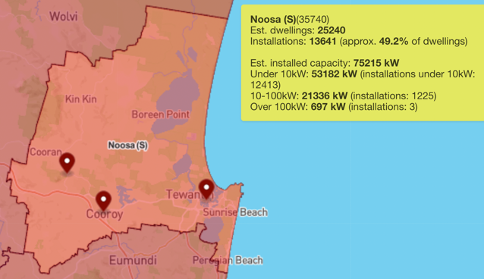
Figure 3
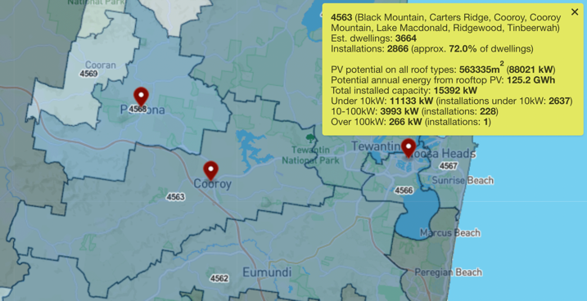
Figure 4
Negative loads at local Zone Substations are increasing - over 260 days in 2021-22 for both Black Mountain and Cooran (see Figure 5). This means during these days, there is more solar electricity being generated than is being consumed in the areas served by these Zone Substations, and much excess solar generation that could be stored for later use, as shown in Figure 6.
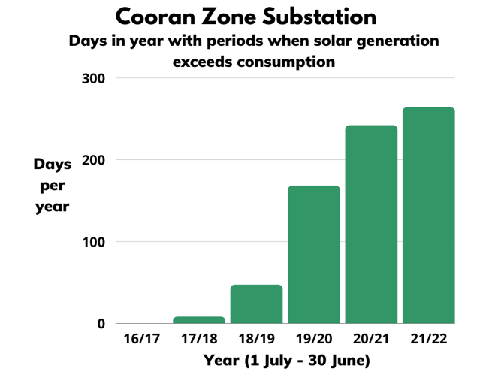
Figure 5
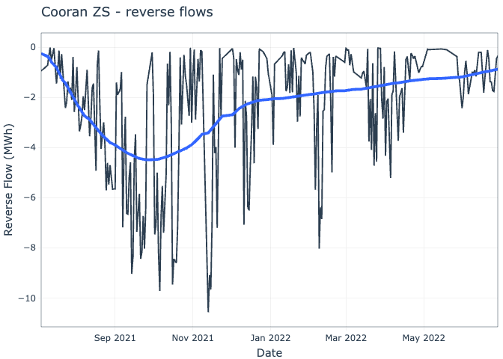
Figure 6
If similar rates of installation continue as shown in Figure 7, we assume that the significant reverse flow through substations - 11kV to LV – will increase, and on these Low Voltage feeders there is the opportunity to “soak up” the excess daytime electricity in a “sponge” to be “squeezed out” for night use by all customers. Figure 8 shows the actual and projected solar export into the low voltage network.
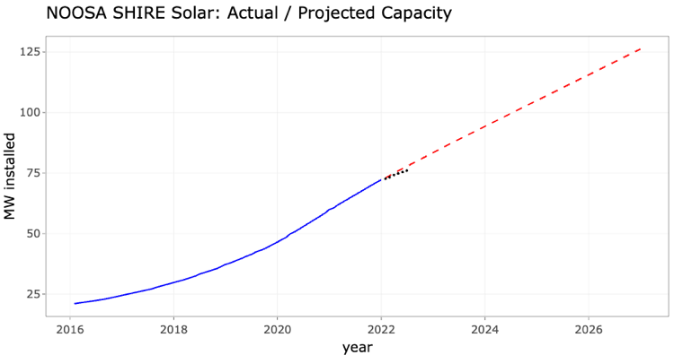
Figure 7
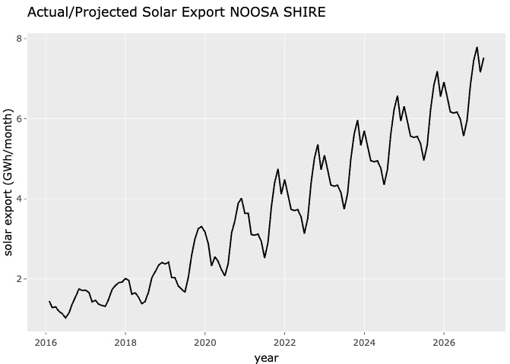
Figure 8

Opportunities
In the Noosa LGA, we have high solar penetration, growing solar exports, and evidence of significant reverse power flows, which all indicate potential for many locations where community batteries could play a significant role.

Across Australia, there is emerging interest in, and trials of local batteries. Community batteries are midway between the large scale batteries at Zone Substations and behind the meter batteries at customer premises. We have considered bigger batteries connected to the medium voltage network, but that would not address reverse flow problems on the LV network. To address reverse flow, energy needs to be absorbed before it comes to the transformer, which points to a need for many smaller batteries throughout the LV network.

Local / Neighbourhood / Community Batteries have the potential to
- alleviate export limits
- reduce losses, by keeping electricity generation, storage and consumption local
- provide network support services on the LV network, addressing the problems where they originate
- facilitate energy equity, by allowing non-solar customers to still benefit from the lower generation costs that rooftop solar PV provides
- defer network upgrade / augmentation costs; and therefore
- contribute to the overall goal of reducing carbon emissions and meeting both State and Federal climate change targets.

A community battery is one that delivers the balance between the competing values of profitability, network support, decarbonisation and community benefit.

Rapid uptake in solar is causing ‘congestion’ in the electricity network, that is, more renewable energy than the grid can handle. Unfortunately, if renewable energy can’t be used, exported to the grid, or stored, it is wasted. Community batteries address this problem by absorbing and storing excess energy from rooftop solar and releasing it during peak times when it is needed most.

At the neighbourhood-scale, costs are shared, making energy supply and storage more affordable for everybody. We can retain energy storage “savings” in our local community.

With community batteries, we can make our energy system more resilient, climate friendly, equitable, and affordable.

The Roadmap
The output from the project will be a plan, more like a “roadmap”.

The intended audience will include
- the Noosa and Hinterland residential and business communities
- local enthusiasts for Community Batteries and the energy transition
- decision makers for stakeholders, which may include Noosa Council, Energex/Energy Queensland, investors, implementers and operators, other LGAs and government policy teams
The roadmap will prepare the groundwork for investors including the Federal Government’s commitment of $500k for a Community Battery in Noosaville, the State Government’s $500 million for grid and community batteries, commercial operators, large green and local investors, and potentially Noosa Council and Energex. The plan will also consider how to scale the business and operational models to potentially well over 100 LV connected batteries.

Roadmap content
The roadmap will cover areas that are relevant to any community battery, as well as considerations for a small number of candidate locations.

General sections will cover
- site selection criteria
- community engagement
- connection to the Energex network
- top-level battery and equipment considerations
- business and financial models
- the operating model (including tariffs)
- land, development and environmental approvals
- identifying partners for implementation of the roadmap
- identifying funding sources

A short-list of candidate sites will be developed with site specific detail for the general sections outlined above.

The chapters of the roadmap will be:

- Introductory (expanding on this project overview)
  - Summary
  - Project Overview
  - Resourcing
- Sites for batteries
  - specify criteria for site selection
  - identify and qualify candidate sites based on criteria
  - assess candidate sites for network suitability
  - we anticipate recommending the first 10-20 sites
  - initial focus may be on locations for mutual Energex / community benefit
- Community Engagement
  - engage with the community to educate and gauge support
- Connection to the Network + Engineering
  - Confirm connection process as per Energex Standard STNW3511 (Dynamic)
  - Engineering required to connect
  - Electrical + civil, site works etc
  - Top level battery specs
  - Propose a Community Battery trial tariff
  - Engage with Energex / Energy Queensland to gain their support and assistance
- Define the business / financial model
  - Options for how business and financial structures are setup for a large number of community batteries
  - Define the preferred philosophy behind the venture, i.e. balance between for-profit, network support, decarbonisation, community benefit
  - Critically review potential models including Yarra Energy Foundation Not-For-Profit hybrid model
  - Define criteria to assess proposed community battery projects in order to benchmark how suited they are to the Noosa community
  - Generic Queensland 10 year financial feasibility study (commissioned by Noosa Council)
- Define the operating model
  - identify all revenue streams and operational costs
    - energy arbitrage
    - Frequency Control Ancillary Services (contingency FCAS)
    - LUOS tariffs
    - customer fees
    - customer payments
    - aggregator fees
    - retailer fees
    - operational and maintenance costs
  - potentially model after Yarra Energy Foundation NFP modelling
  - ensure that all cost centres are covered by revenue streams, so the community batteries are financially sustainable
  - this section would not be applicable for commercially owned and operated models
- Land, Development Approvals, Environmental Approvals
  - in conjunction with, and mainly delivered by Noosa Council and always subject to local community support
  - identify suitable land parcels for location of batteries and associated switchgear, for identified candidate sites
  - this may include Council land parcels
  - identify Council Development Approval requirements for community batteries
  - identify any Council environmental requirements for community batteries, such as noise, visual amenity, safety, etc.
- Identify partners for implementation of the Plan, which may include:
  - Noosa Council
  - Energy Queensland / Energex
  - Yarra Energy Foundation consortium
  - Community Scale Battery Working Group
  - Electricity aggregator (for access to wholesale and FCAS markets)
  - Electricity retailers (for access to the retail market and customers)
  - Commercial partners
- Identify funding sources, which may include
  - Federal Government, via ALP election commitment for $500k community battery at Noosaville
  - State Government - $500 million for grid and community batteries
  - Commercial partners
  - Noosa Council
  - Large Green investors
  - Local investors
  - Energex
  - ARENA
- Shortlist of candidate sites
  - site specific detail for the general sections outlined above

Resourcing
In line with the advice from the Community Scale Battery Working Group’s Making community batteries work at scale in Australia, the project will adopt a co-design process, rather than be an expert’s report. Due to the limited budget, much of the work is planned to be conducted by local volunteers, with access to experts, and supplemented by other partners and stakeholders.

The project will be managed and delivered by a Steering Group who have provided the core technical and business direction which lead to the successful grant application.

Experts include:
- Chris Wallin - Commercial Program Manager - Yarra Energy Foundation(YEF). The YEF Community Battery program saw metropolitan Melbourne’s first community battery go live in June 2022. YEF have a scalability plan to rollout 200 community batteries over a seven-year period. Drawing on their experience in developing the YEF Community Battery program, Chris will advise how the YEF work could be adapted to the local Noosa conditions. (linkedin profile) Chris has been advising the ZEN team over the course of their Community Battery journey
- Steve Fairless – Power Oracle. Steve has vast experience in the Electricity Utility Industry for 50 years across 2 States and 4 Utilities. He formed Power Oracle post retirement following approaches by Veolia Energy to continue Advice Work regarding Renewable Energy and Zero Carbon Goals for The University of the Sunshine Coast. His previous position was Principal Asset Officer for Enegex – North Coast. (linkedin profile) Steve has been advising the ZEN team over the course of their Community Battery journey
- The Social Deck. Noosa-based The Social Deck helps organisations to reach and engage people in actions that have a positive impact on society and the environment. They specialise in strategic communications, stakeholder and community engagement, capacity building, digital strategy, social marketing campaigns and evaluation. The group provides consultancy services to government agencies, businesses, social enterprises and not-for-profits to help them achieve change. As testament to the relationship between Zero Emissions Noosa and The Social Deck, and to their commitment to the project and the local community, we are delighted to say in their words - “We are pleased to partner with ZEN on delivery of this project and will provide the services outlined above on a pro-bono basis.” ZEN has previously engaged The Social Deck.

Members of the Steering Group will include:
- Geoff Acton as co-convenor – long-term ZEN active member, and experienced software development and consulting project manager. Geoff has been a key driver of ZEN’s community battery initiative since mid 2021 and is convenor of the ZEN battery group, working with leaders in the Community Battery space, including Chris Wallin(YEF), Heather Smith, Steve Fairless, Noosa Council and the Community Scale Battery Working Group. He managed ZEN’s Roadmap to 100% renewable electricity study with ITP Renewables, and plays key roles with ZEN’s social media presence, website, and data collation and analysis of electricity usage and DER data. (linkedIn profile)
- Vivien Griffin as co-convenor. Vivien was the founder of Zero Emissions Noosa in 2016, and first convenor of ZEN’s community battery working group. She has been the organiser of the annual Noosa Electric Vehicle Expo, and is an ex-Councillor for both the Noosa Council and Sunshine Coast Council, as well as past president of the Sunshine Coast Environment Council (linkedin profile)
- Annie Nolan is Noosa Council's Carbon Reduction Officer. Annie will provide support for identifying potential sites with high solar penetration by using Council mapping tools, liaising with Council staff to assist identifying suitable Council land parcels for community batteries, liaise re Council Development Approval requirements for community batteries, including any Council environmental requirements for community batteries, such as noise, visual amenity, etc., and keeping relevant Council stakeholders up to date with the project (linkedIn profile)
- Heather Smith - Energy Specialist and Community Energy Specialist. Heather was co-author of an initial study ZEN commissioned to kick-start our community battery initiative and has continued to advise as a member of the ZEN community battery working group (linkedin profile)
- Sajeeb Saha - Senior Lecturer Electrical Engineering - University of Sunshine Coast – is a member of the ZEN working group (Uni SC profile)
- Steve Fairless – see above
- Chris Wallin – see above
- ZEN Board Representative – TBA

Other team members
- Meghan Halverson – ZEN’s Community Engagement Officer
- Other volunteers to be announced

Partners
- To be confirmed

Consortium
In the Federal Budget, it was announced “The Government will provide $224.3 million over 4 years from 2022–23 to deploy 400 community batteries across Australia”. It is expected that the first round will open shortly and will be managed by ARENA.

ZEN has been approached by Yarra Energy Foundation to join a consortium which will make a submission in the first round for a network of up to 10 community batteries, with 2 in the Noosa LGA. The network of batteries would be managed centrally by YEF using the same infrastructure and suppliers as used for the YEF North Fitzroy commissioned system.
Being part of the consortium is totally in alignment with our Roadmap project. All the preliminary work we'd be doing with the consortium would be work we'd be doing as part of the roadmap project. But the consortium work would drive our priorities, maybe with slightly differing sequencing.

Acknowledgement
This project has received funding support from the Queensland Government’s Community Sustainability Action grant program.

https://apps.des.qld.gov.au/sustainability-action-grants/?round=6&lga=noosa-shire-council
Chris Bowen, Minister for Climate Change and Energy, announces Community Battery for Noosaville as part of the Power to the People plan to deploy 400 community batteries across the country with an investment of $200 million. ZEN has compiled a list of other commitments made for Queensland sites.
Queensland Energy and Jobs Plan (September 2022) – Action 1.3 – page 26
https://apps.des.qld.gov.au/sustainability-action-grants/?round=6&lga=noosa-shire-council
https://www.aemc.gov.au/sites/default/files/2021-03/ERC0311%20-%20draft%20-%20FAQs.pdf, March 2021
Queensland Energy and Jobs Plan (September 2022)
Noosa Climate Change Response Plan
Australian Energy Market Operator (AEMO) – 2022 Integrated System Plan
Powering Australia Plan – Australian Government Department of Climate Change, Energy, the Environment and Water
Powering Australia Plan – PDF document
Power to the People summary
The Community Scale Battery Working Group is an informal collaboration of staff from environmental and community energy groups, network operators, research institutions, retailers and governments around Australia. The objective of the CSBWG is to give community scale/neighbourhood batteries the best possible chance of becoming an important part of the energy transition.
Making community batteries work at scale in Australia
Australian PhotoVoltaic Institute as at 30 June 2022 – Noosa LGA and Postcode 4563(Cooroy + districts)
ZEN analysis of Energex Zone Substation Load data – as at 30 June 2022
ZEN analysis of Clean Energy Regulator postcode data and Energex Usage Data – as at 31 March 2022
Chris Bowen, Minister for Climate Change and Energy, announces Community Battery for Noosaville as part of the Power to the People plan to deploy 400 community batteries across the country with an investment of $200 million. ZEN has compiled a list of other commitments made for Queensland sites.
Queensland Energy and Jobs Plan (September 2022) – Action 1.3 – page 26
noting that CitiPower/Powercor/United Energy(Victoria), Ausgrid(NSW), Essential Energy(NSW) & EvoEnergy(ACT) all have community battery tariffs trials in place for 2022-23 approved by the Australian Energy Regulator
To get to 200+ batteries will likely require a mixture of models, hence criteria to assess various proposals
Making community batteries work at scale in Australia
https://www.yef.org.au/community-batteries/ and https://www.yef.org.au/community-batteries/yarra-community-battery-trial/
The Social Deck
Roadmap to 100% renewable electricity
Facilitating Community Understanding of Electricity Battery Options for Noosa Shire

